**Module 2 Assignment: Variables and Constants with Arithmetic Calculations using Flowcharting**

**Exercise 1**

Draw the hierarchy chart and design the logic for a program that calculates service charges for Hazel’s Housecleaning service. The program contains housekeeping, detail loop, and end-of-job modules. The main program declares any needed global variables and constants and calls the other modules. The housekeeping module displays a prompt for and accepts a customer’s last name. While the user does not enter ZZZZ for the name, the detail loop accepts the number of bathrooms and the number of other rooms to be cleaned. The service charge is computed as $40 plus $15 for each bathroom and $10 for each of the other rooms. The detail loop also displays the service charge and then prompts the user for the next customer’s name. The end-of-job module, which executes after the user enters the sentinel value for the name, displays a message that indicates the program is complete. (2.1, 2.2, 2.4)

1. **Flowchart**

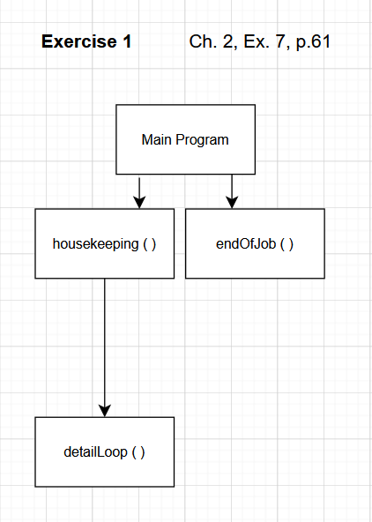

**B. planning the logic**

**PROGRAM**

Main Module

Declare string customerName

Declare numBathrooms, NumOtherRooms

Declare serviceCharge

Constant BASE_CHARGE = 15

Constant BATHROOM_CHARGE = 15

Constant ROOM_CHARGE = 10

Call Housekeeping (customerName)

While customerName != “ZZZZ”

Call DetailLoop (customerName, numBathrooms, numOtherRooms, serviceCharge)

Call Housekeeping(customerName)

End While

Call EndOfJob()

End Main

**HOUSEKEEPING**

Housekeeping (customerName)

Display “Enter customer’s last name (or ZZZZ to quit): “

input customerName

End Housekeeping

**Detail Loop**

DetailLoop(customerName, numBathrooms, numOtherRooms, serviceCharge)

Display “Enter number of bathrooms for “ + customerName + “: “

Input numOtherRooms

serviceCharge = BASE_CHARGE + (BATHROOM_CHARGE * numBathrooms) + (ROOM_CHARGE * numOtherRooms)

Display “Service charge: $ “ + serviceCharge

End DetailLoop

**EndOfJob**

EndOfJob()

Display “Program Complete.”

End EndOfJob